耐燃電纜Fire Resistant Cable
600V XLPE絕緣聚氯乙烯或低煙無鹵被覆耐燃電纜-單芯
600V XLPE Insulated, PVC OR LSHF Jacketed Fire Resistant Cable-Single Core
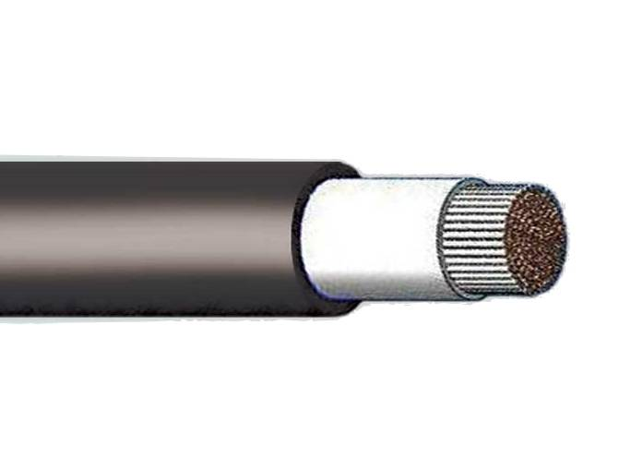
JACKET_PVC or
CONDUCTOR_BARE COPPER
INSULATION_XLPE
LSHF
Construction:

Conductor |  | Insulationthickness | Jacket  thickness | Overall diameter  (approx.) | AC test  voltage | max. Conductorresistance20℃ | min.Insulation  Resistance20℃ | Length
sq. mm | No./mm | mm. | mm. | mm. | kV/5min | ohm/km | MΩ-km | m
- | 1/1.0 | 0.8 | 1.5 | 6.4 | 1.5 | 22.8 | 2500 | 300
- | 1/1.2 | 0.8 | 1.5 | 6.6 | 1.5 | 15.8 | 2500 | 300
- | 1/1.6 | 0.8 | 1.5 | 7.0 | 1.5 | 8.92 | 2500 | 300
- | 1/2.0 | 0.8 | 1.5 | 7.4 | 1.5 | 5.65 | 2500 | 300
- | 1/2.6 | 1.0 | 1.5 | 8.4 | 1.5 | 3.35 | 2500 | 300
1.25 | 7/0.45 | 0.8 | 1.5 | 6.8 | 1.5 | 16.5 | 2500 | 300
2.0 | 7/0.6 | 0.8 | 1.5 | 7.2 | 1.5 | 9.24 | 2500 | 300
3.5 | 7/0.8 | 0.8 | 1.5 | 7.8 | 1.5 | 5.20 | 2500 | 300
5.5 | 7/1.0 | 1.0 | 1.5 | 8.8 | 1.5 | 3.33 | 2500 | 300
8 | 7/1.2 | 1.0 | 1.5 | 9.4 | 1.5 | 2.31 | 2000 | 300
 | 壓縮  Compacted circular |  | 1.5 | 9.2 |  | 2.29 | 2000
14 | 7/1.6 | 1.0 | 1.5 | 11.0 | 2.0 | 1.30 | 1500 | 300
 | 壓縮  Compacted circular |  | 1.5 | 10.5 |  | 1.31 | 1500
22 | 7/2.0 | 1.2 | 1.5 | 12.5 | 2.0 | 0.824 | 1500 | 300
 | 壓縮  Compacted circular |  | 1.5 | 12.0 |  | 0.832 | 1500
30 | 7/2.3 | 1.2 | 1.5 | 13.5 | 2.0 | 0.623 | 1500 | 300
 | 壓縮  Compacted circular |  | 1.5 | 13.0 |  | 0.610 | 1500
38 | 7.8 | 1.2 | 1.5 | 14.5 | 2.5 | 0.487 | 1500 | 300
 | 壓縮  Compacted circular |  | 1.5 | 14.0 |  | 0.481 | 1500
50 | 19/1.8 | 1.5 | 1.5 | 16.5 | 2.5 | 0.378 | 1500 | 300
 | 壓縮  Compacted circular |  | 1.5 | 16.0 |  | 0.366 | 1500
60 | 19/2.0 | 1.5 | 1.5 | 17.0 | 2.5 | 0.303 | 1500 | 300
 | 壓縮  Compacted circular |  | 1.5 | 16.5 |  | 0.305 | 1500
80 | 19/2.3 | 1.5 | 1.5 | 19.0 | 2.5 | 0.229 | 1500 | 300
 | 壓縮  Compacted circular |  | 1.5 | 18.0 |  | 0.229 | 1500
100 | 19/2.6 | 2.0 | 1.5 | 21.0 | 3.0 | 0.180 | 1500 | 300
 | 壓縮  Compacted circular |  | 1.5 | 20.0 |  | 0.183 | 1500
125 | 19/2.9 | 2.0 | 1.6 | 23.0 | 3.0 | 0.144 | 1000 | 300
 | 壓縮  Compacted circular |  | 1.5 | 22.0 |  | 0.146 | 1000
150 | 37/2.3 | 2.0 | 1.7 | 25.0 | 3.0 | 0.118 | 900 | 300
 | 壓縮  Compacted circular |  | 1.6 | 23.0 |  | 0.122 | 1000
200 | 37/2.6 | 2.5 | 1.8 | 28.0 | 3.0 | 0.0922 | 900 | 200
 | 壓縮  Compacted circular |  | 1.7 | 27.0 |  | 0.0915 | 1000
250 | 61/2.3 | 2.5 | 1.9 | 31.0 | 3.0 | 0.0722 | 900 | 200
 | 壓縮  Compacted circular |  | 1.8 | 29.0 |  | 0,0739 | 1000
325 | 61/2.6 | 2.5 | 2.0 | 33.5 | 3.0 | 0.0565 | 800 | 200
 | 壓縮  Compacted circular |  | 1.9 | 32.0 |  | 0.0568 | 900
400 | 61/2.9 | 2.5 | 2.1 | 36.5 | 3.0 | 0.0454 | 700 | 150
 | 壓縮  Compacted circular |  | 2.0 | 34.5 |  | 0.0462 | 800
500 | 61/3.2 | 3.0 | 2.2 | 40.0 | 3.5 | 0.0373 | 800 | 150
 | 壓縮  Compacted circular |  | 2.2 | 38.5 |  | 0.0369 | 800
600 | 91/2.9 | 3.0 | 2.4 | 44.0 | 3.5 | 0.0304 | 700 | 150
 | 壓縮  Compacted circular |  | 2.3 | 41.5 |  | 0.0308 | 800
800 | 127/2.8 | 3.5 | 2.6 | 50.0 | 3.5 | 0.0234 | 800 | 150
 | 壓縮  Compacted circular |  | 2.5 | 48.0 |  | 0,0231 | 800

